

Project Report

Title: Treasure Hunt Game Using(BFS,DFS,UCS,A*)

Course Code: CSE-432
Course Title: Artificial Intelligence Laboratory

Submitted By
Mst Monira khatun
ID:222400019

Submitted To
Tazeen Tasneem
Assistant Professor
Faculty of Engineering and Technology
Eastern University

1. Introduction
Artificial Intelligence (AI) is a branch of computer science that focuses on creating intelligent systems capable of performing tasks that typically require human intelligence.These tasks include problem-solving, decision-making, reasoning, learning, and planning.One of the most fundamental areas of AI is search algorithms, which allow an agent to explore possible states in a problem space and identify a solution efficiently.
In this project, I developed a Treasure Hunt Game, a simulation in which an AI agent navigates through a grid-based environment to locate a treasure. The agent begins at a predefined start position, encounters obstacles along the way, and must determine the most efficient path to reach the goal. The project implements four classical AI search algorithms:
- Breadth First Search (BFS)
- Depth First Search (DFS)
- Uniform Cost Search (UCS)
- A* (A-star) Search
The game demonstrates how AI search techniques can be used to solve practical pathfinding problems in a controlled environment, simulating real-world scenarios like robotics navigation, game AI, and automated rescue operations.

2. Objective of the Project
The main objectives of this project are as follows:
- To understand the fundamental working principles of AI search algorithms and their practical applications.
- To implement BFS, DFS, UCS, and A* algorithms using Python in a structured environment.
- To solve a grid-based pathfinding problem where obstacles exist, simulating real-world constraints.
- To analyze and compare the performance of different search algorithms in terms of efficiency, optimality, and exploration strategy.
- To enhance problem-solving and algorithmic thinking skills using AI concepts.
- To provide a framework for future AI projects involving path planning, game AI, or autonomous navigation.

3. Features of the Project
This Treasure Hunt Game project has several notable features:
- Grid-based environment:
The environment is represented as a two-dimensional grid, making it easier to visualize the agent's movement and the effects of obstacles.
- Clear representation of game elements:
  - S – Start position (agent's initial location)
  - T – Treasure (goal)
  - 1 – Obstacles (cannot be crossed)
  - 0 – Free path (agent can move)
- Agent movements:
The agent can move in four directions: up, down, left, right.
- Multiple search algorithm support:
The system allows BFS, DFS, UCS, and A* to be run independently for comparison.
- Optimal and non-optimal paths:
BFS, UCS, and A* guarantee shortest paths (under certain conditions), while DFS demonstrates deep exploration behavior but may not be optimal.
- Simple Python implementation:
The code is readable, modular, and suitable for academic purposes, exams, or practical lab demonstrations.
- Educational value:
Students can learn about AI search strategies, heuristics, and algorithm efficiency while visualizing how an AI agent solves a problem.
- Future-ready framework:
The project can be enhanced with graphical visualization, weighted paths, dynamic obstacles, or multi-treasure scenarios.

4. Game Description
The Treasure Hunt Game is designed using a 2D grid environment. Each cell in the grid represents a particular state:
- S – Start: The agent begins its journey from this position.
- T – Treasure (Goal): The target destination the agent must reach.
- 1 – Obstacle: Cells that the agent cannot traverse.
- 0 – Free path: Cells that the agent can move into.

Example Grid (5x5):
S 0 1 0 0
0 0 1 0 1
1 0 0 0 0
0 1 1 1 0
0 0 0 T 0
- Start = (0,0)
- Treasure = (4,3)
- The agent must navigate around obstacles to reach the treasure.
This is a classic pathfinding problem, widely used in AI to demonstrate:
- Decision-making under constraints
- Optimality and efficiency of search algorithms
- Comparison between uninformed (DFS, BFS) and informed (A*) strategies
The agent evaluates possible moves from its current position, avoids blocked paths, and progresses toward the goal. Obstacles simulate real-world constraints, such as walls or hazards, which the agent cannot traverse.

5. Algorithms Used

5.1 Breadth First Search (BFS)
Concept: BFS explores the search space level by level, starting from the initial node and exploring all neighbors before moving deeper.
Characteristics:
- Uses a queue (FIFO) to track nodes.
- Guarantees the shortest path if all moves have equal cost.
- Requires more memory because it stores all nodes at the current level.
Application in Game: BFS explores the grid systematically and ensures that the shortest path to the treasure is found.
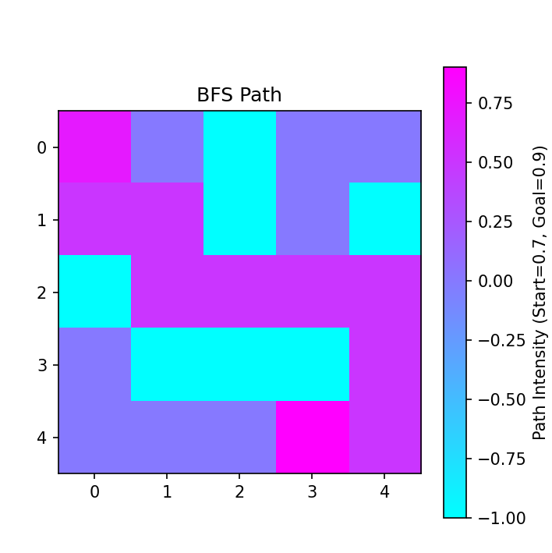
Path Output visualization:

5.2 Depth First Search (DFS)
Concept: DFS explores as deep as possible along a path before backtracking.
Characteristics:
- Uses a stack (LIFO) or recursion to explore nodes.
- Less memory usage compared to BFS.
- Does not guarantee optimal paths; may find longer routes first.
Application in Game: DFS demonstrates a deep exploration strategy, allowing comparison with BFS for pathfinding efficiency.
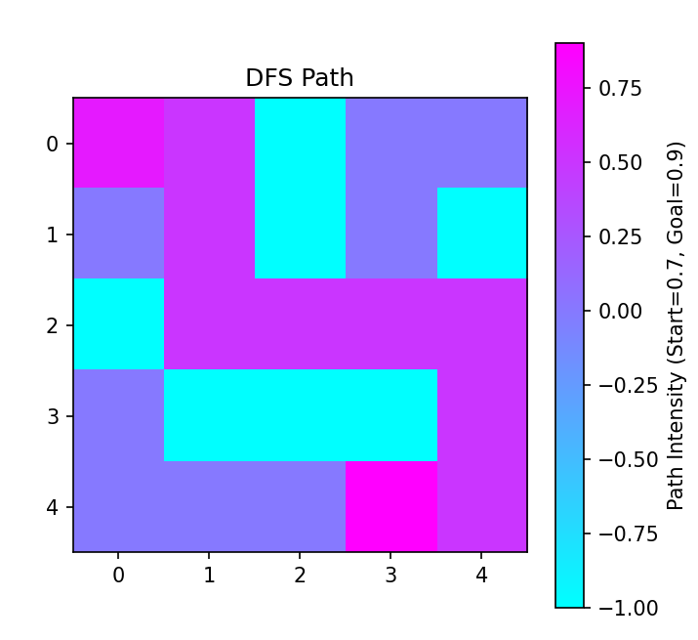
Path Output visualization:

5.3 Uniform Cost Search (UCS)
Concept: UCS is a cost-based search algorithm that always expands the node with the lowest total path cost first.
Characteristics:
- Uses a priority queue to manage nodes by cost.
- Guarantees optimal solutions if all move costs are positive.
- Can be slower for large search spaces due to exhaustive exploration.
Application in Game: UCS ensures that the path chosen is cost-efficient, making it ideal for environments where movement cost varies.

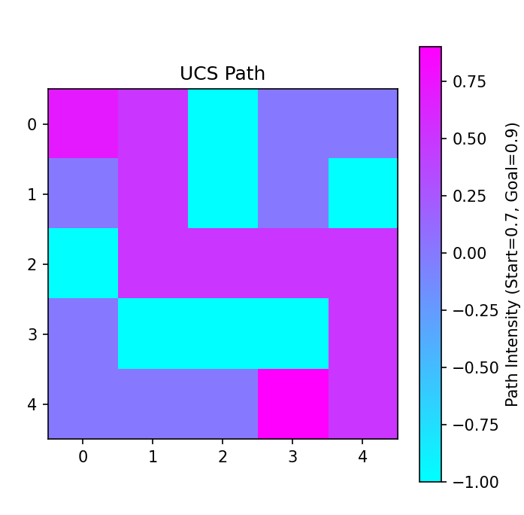
Path Output visualization:

5.4 A Search Algorithm*
Concept: A* is an informed search algorithm combining the path cost and a heuristic to guide exploration efficiently.
Evaluation Function:
f(n) = g(n) + h(n)
Where:
- g(n) = path cost from start to current node
- h(n) = heuristic estimate of cost from current node to goal (Manhattan distance)
Characteristics:
- Combines the accuracy of UCS with efficiency of heuristic guidance.
- Explores fewer nodes compared to BFS or UCS.
- Guarantees optimal path if heuristic is admissible.
Application in Game: A* efficiently guides the agent through the grid, reducing exploration time while ensuring the shortest path to the treasure.
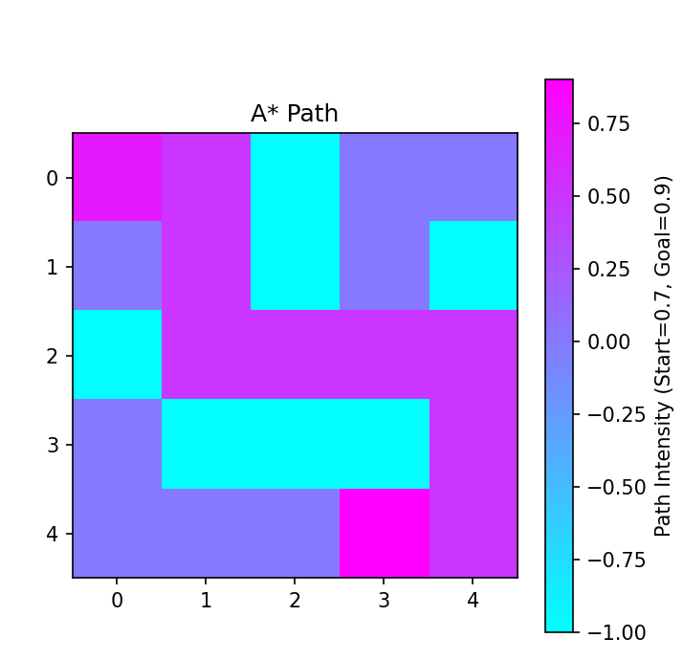
Path Output visualization:

6. Result and Discussion
The game was executed for all four algorithms on the 5x5 grid. The results are as follows:
- BFS: Explores systematically, finds shortest path.
- DFS: Explores deep paths, may not be shortest.
- UCS: Ensures least cost path is selected.
- A*: Most efficient, fewer nodes explored, fast convergence.

Screenshot of Output:
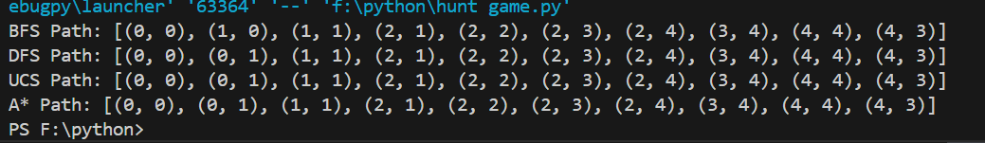

Output showing paths for BFS, DFS, UCS, and A* in the Treasure Hunt Game.

Observation:
- BFS and UCS guarantee optimal paths.
- DFS may take longer or different path.
- A* demonstrates the power of heuristic guidance in reducing search time.

7. Conclusion
The Treasure Hunt Game can be improved or extended as follows:
- Graphical User Interface (GUI): For visualizing the agent’s movement dynamically.
- Diagonal Movements: Allowing movement in 8 directions.
- Multiple Treasures: Introducing several goals in the grid.
- Weighted Paths: Assigning different costs to different terrain types.
- Dynamic Obstacles: Moving or changing obstacles to simulate real-world complexity.
- Real-time Animation: Showing step-by-step decision making.
- Algorithm Comparison Metrics: Graphs comparing execution time, nodes explored, and optimality.
This mini project demonstrates the practical application of AI search algorithms in solving a grid-based treasure hunt problem.
- BFS and UCS guarantee optimal paths.
- DFS demonstrates deep search but may produce sub-optimal paths.
- A* combines path cost and heuristic guidance, achieving efficient and optimal pathfinding.
The project provides a solid foundation for understanding search algorithms in AI, their practical implementation in Python, and their real-world applicability in robotics, game AI, and pathfinding problems.

